Project Documentation

1. Introduction

Project Title
Sports Hall Booking System By Service Portal

Team Members
Although the original template is designed for a team project, this project was completed individually.
Name | Role
Veldurthi Hemanth | Requirement Analysis, UI Design, Service Portal Development, Database Design, Client-side Scripting, Server-side Scripting, Testing, Documentation

Introduction
The Sports Hall Booking System is a web-based application developed using the ServiceNow Service Portal to automate the process of reserving sports facilities within an institution. The system replaces the traditional manual booking process with a centralized online platform, allowing users to reserve sports halls quickly and efficiently.
The project demonstrates the use of ServiceNow as an enterprise application development platform by integrating Service Portal widgets, Client Controllers, Server Scripts, GlideRecord APIs, and custom database tables to build a complete real-world booking application. The system provides a simple, reliable, and user-friendly solution that improves transparency, reduces administrative effort, and ensures efficient utilization of sports facilities.

2. Project Overview

Purpose
The purpose of the Sports Hall Booking System is to simplify the sports hall reservation process by providing an online booking platform through the ServiceNow Service Portal. The system eliminates manual booking methods and enables users to reserve sports facilities easily by selecting a sport, booking date, and available time slot. It also prevents duplicate bookings and stores reservation details securely in the ServiceNow database.

Features
The Sports Hall Booking System provides the following major features:

1. Online Sports Hall Booking
Users can reserve sports halls directly through the ServiceNow Service Portal without visiting the sports office.

2. Sport Selection
Users can select the required sport from the available dropdown list.
Supported sports include:
- Basketball
- Badminton
- Cricket
- Volleyball
- Table Tennis

3. Booking Date Selection
Users can choose the preferred booking date using a calendar interface.

4. Available Slot Display
The system automatically displays only the available one-hour booking slots after the sport and date are selected.

5. Duplicate Booking Prevention
Server-side validation ensures that the same hall and time slot cannot be booked more than once.

6. Automatic Booking Charge
Booking charges are displayed automatically based on the selected sport.

7. Secure Database Storage
All booking information is stored securely in the custom Sports Hall Bookings table within ServiceNow.

8. Booking Confirmation
After successful booking, the user receives a confirmation message and is redirected to the Sports Zone home page.

9. Cancel Booking
Users can cancel the booking process at any time and return to the home page.

10. Responsive User Interface
The Service Portal provides a clean and responsive interface that works efficiently on desktop and laptop browsers.

Modules of the Project
The application consists of the following major modules:
Module | Description
Home Page | Entry point of the Sports Zone portal.
Book Venue | Allows users to reserve sports halls.
Available Slots | Displays only available one-hour booking slots.
My Bookings | Displays booking details of the logged-in user.
Contact | Provides contact information for support.
Database | Stores booking records in ServiceNow.

Objectives
- Automate sports hall reservations.
- Reduce manual booking errors.
- Prevent duplicate bookings.
- Display real-time slot availability.
- Improve user convenience.
- Maintain booking records securely.
- Simplify sports facility management.
- Provide a scalable solution for future enhancements.

3. Architecture

Frontend Architecture
The frontend of the Sports Hall Booking System is developed using the ServiceNow Service Portal, which provides a responsive and user-friendly web interface. The portal consists of multiple pages and widgets that allow users to interact with the booking system. HTML is used to design the page structure, CSS provides styling and responsive layouts, while AngularJS (Client Controller) handles user interactions and dynamic content updates.
The Book Venue widget allows users to select a sport, choose a booking date, view available time slots, and confirm bookings. Client-side scripting communicates with the server using ServiceNow APIs to retrieve booking information without reloading the page.

Frontend Components
- Sports Zone Home Page
- Book Venue Widget
- My Bookings Page
- Contact Page
- HTML Templates
- CSS Styling
- AngularJS Client Controller

Backend Architecture
The backend is implemented using ServiceNow Server Scripts and GlideRecord API. The server script processes requests received from the client controller, validates user inputs, checks slot availability, prevents duplicate bookings, calculates booking charges, and stores booking information in the database.
The backend also returns available slots dynamically whenever the user selects a sport and booking date.

Backend Responsibilities
- Process booking requests
- Validate booking information
- Retrieve available slots
- Prevent duplicate bookings
- Insert booking records
- Communicate with the ServiceNow database

Database Architecture
The Sports Hall Booking System stores all booking information in a custom ServiceNow table named:
Sports Hall Bookings
Each booking record contains essential reservation details that are used for validation and booking management.

Main Fields
Field Name | Description
Hall Name | Selected sport or hall
Start Time | Booking start time
End Time | Booking end time
Booking Charge | Charge for selected sport
Status | Current booking status
Payment Status | Payment information
Booked By | User who created the booking
The database interacts with the backend through the GlideRecord API to retrieve and update booking information efficiently.
Architecture Workflow :
User
│
▼
Sports Zone Service Portal
│
▼
Book Venue Widget
(HTML + CSS + AngularJS)
│
▼
Client Controller
│
▼
Server Script
│
▼
GlideRecord API
│
▼
Sports Hall Booking Table
(ServiceNow Database)
│
▼
Booking Confirmation

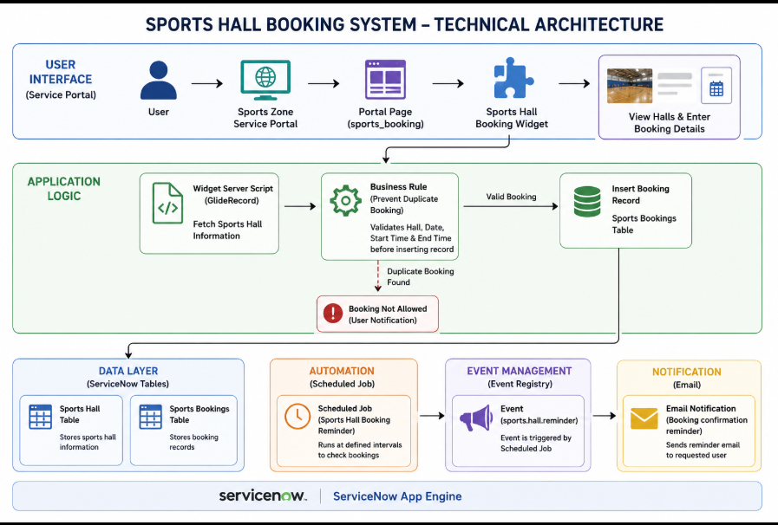

Technical Architecture Components
- Platform: ServiceNow App Engine
- User Interface: Service Portal (Sports Zone)
- Portal Page: Sports Booking (sports_booking)
- Custom Widget: Sports Hall Booking Widget
- Frontend Technologies: HTML, CSS, JavaScript, AngularJS
- Backend Scripting: GlideRecord, Business Rules (Server-side JavaScript)
- Database: Custom ServiceNow Tables
  - Sports Hall
  - Sports Bookings
- Automation: Scheduled Job
- Event Management: Event Registry (sports.hall.reminder)
Notifications: Email Notification (Booking Confirmation Reminder)

System Workflow
- The user opens the Sports Zone Service Portal.
- The portal displays available sports halls using a custom widget.
- The user selects a sports hall and enters booking details.
- The Business Rule validates the booking to prevent duplicate reservations.
- If the booking is valid, the record is stored in the Sports Bookings table.
- The Scheduled Job triggers the registered event when required.
- The Event Registry activates the configured Email Notification to send booking reminders.

4.Setup Instructions

The Sports Hall Booking System was developed and tested using the ServiceNow Personal Developer Instance (PDI). The following setup steps were performed before implementing the application.

4.1 Prerequisites

Before setting up the project, ensure the following requirements are available:

ServiceNow Personal Developer Instance (PDI)

System Administrator (admin) access

Modern web browser (Google Chrome or Microsoft Edge)

Stable internet connection

Basic knowledge of the ServiceNow platform

4.2 Environment Setup
- Log in to the ServiceNow Personal Developer Instance.
- Create a new Scoped Application named Sports Hall Booking System.
- Create the required custom tables:
  - Sports Hall Bookings
- Configure the required table fields based on project requirements.
- Insert sample sports hall records for testing.
- Configure the Sports Zone Service Portal.
- Create the Sports Booking portal page.
- Develop and attach the custom Sports Hall Booking Widget to the portal page.
- Configure the Business Rule to prevent duplicate bookings.
- Create the Event Registry and Email Notification.
- Configure the Scheduled Job for booking reminder events.
- Test the application by creating booking records and verifying validations and notifications.

4.3 Technologies Used
Component | Technology
Platform | ServiceNow App Engine
Frontend | Service Portal
UI Development | HTML, CSS, AngularJS, JavaScript
Backend Logic | GlideRecord, Business Rules
Database | ServiceNow Custom Tables
Automation | Scheduled Job
Notification | Event Registry, Email Notification

4.4 Application Components
The project consists of the following ServiceNow components:
- Scoped Application
- Sports Hall Table
- Sports Bookings Table
- Business Rule
- Scheduled Job
- Event Registry
- Email Notification
- Service Portal
- Sports Booking Page
- Custom Service Portal Widget

4.5 Verification
After completing the setup, verify the following:
- Sports halls are displayed on the Service Portal.
- Booking records are successfully created.
- Duplicate bookings are prevented.
- Booking details are stored in the Sports Bookings table.
- Scheduled Job executes successfully.
- Event Registry triggers the configured Email Notification.

5.Folder Structure:

• Client
The client-side folder structure defines the user interface components, logic, and state management rendering inside the Sports Zone Service Portal. It handles user interactions, calendar rendering, and instant client-side scheduling validations.

├── client/ # Frontend UI Root Directory
│ ├── components/ # Reusable UI building blocks
│ │ ├── CalendarView/ # Interactive grid tracking facility booking slots
│ │ ├── BookingForm/ # Input fields (Date, Start/End Time, Court Type)
│ │ └── Navbar/ # Top portal navigation panel
│ ├── pages/ # Main landing templates
│ │ ├── Home/ # Main dashboard showcasing sports halls
│ │ ├── BookVenue/ # Primary facility reservation layout
│ │ └── MyBookings/ # Individual user booking history logs
│ ├── styles/ # Global UI presentation logic
│ │ └── main.css # Custom CSS overrides for Service Portal themes
│ ├── utils/ # Client helper modules
│ │ └── dateTimeFormat.js # Client-side time formatting and local conversions
│ └── App.js # Core frontend entry point routing user actions

Server
The server-side organization controls the backend processing, relational tables, and validation engines. It operates as the secure layer executing access permissions, preventing simultaneous slot overlaps, and structuring direct transaction outputs.
├── server/ # Backend Logic Root Directory
│ ├── config/ # System configuration and structural settings
│ │ └── db.js # Structural mapping to the Sports Hall table
│ ├── controllers/ # Logic controllers managing requests
│ │ └── bookingController.js# Computes slot checks, pricing, and execution flows
│ ├── models/ # Database schema templates mapping schema fields
│ │ └── BookingSchema.js # Definitional layer mapping fields (Hall Name, Status, Booked By)
│ ├── routes/ # Endpoint paths receiving incoming portal actions
│ │ └── bookingRoutes.js # Routes routing actions (Create Booking, Fetch My Bookings)
│ ├── scripts/ # Evaluation engines running on data adjustments
│ │ ├── businessRules.js # Platform triggers ensuring validation against double-bookings
│ │ └── flowDesigner.js # Post-submission pipeline routing manager approvals
│ └── server.js # Core backend engine orchestrating platform services

6. Running the Application

To run the Sports Hall Booking System, follow these steps:
- Log in to the ServiceNow Developer Instance.
- Open the Sports Hall Booking System application.
- Ensure that the required Sports Hall records are available in the Sports Hall table.
- Open the Sports Booking Service Portal using the portal URL:
- https://<instance-name>.service-now.com/sp?id=sports_booking
- The portal displays all available sports halls with their details, including sport type, location, capacity, hourly charge, and availability status.
- Click the Book Now button for the desired sports hall.
- Enter the Booking Date, select available slot
- Charge is displayed when you select sport, it automatically updates for each selected sport
- Click Submit Booking to create the booking request.
- If the selected hall is already booked for the same date in available slots occupied slot won’t appear and prevents the duplicate booking.
- After a successful booking, the booking record is stored in the Sports hall Bookings table, email notifications are triggered, and reminder events are handled through the configured Event Registry and Scheduled Job.

7. API
The Sports Hall Booking System does not use any external REST APIs or third-party API integrations. The application is built entirely within the ServiceNow platform and uses its built-in server-side APIs for data processing and business logic.
Internal ServiceNow APIs Used
API | Purpose
GlideRecord | Used to retrieve, insert, and update records in the Sports Hall and Sports Bookings tables.
GlideSystem (gs) | Used for server-side operations such as retrieving the logged-in user and system functions.
Server Script API | Used to exchange data between the Service Portal widget and the ServiceNow database.

8. Authentication
The Sports Hall Booking System uses ServiceNow's built-in authentication mechanism to provide secure access to the application. Users must log in to the ServiceNow instance using valid credentials before accessing the application or the Service Portal.
Authentication and user management are handled entirely by the ServiceNow platform, ensuring that only authorized users can access application data and perform booking operations. The application also uses ServiceNow's role-based access control to protect records and system components.

Authentication Features

ServiceNow username and password authentication.

Secure login through the ServiceNow platform.

Access restricted to authenticated users.

Role-based access control for application resources.

User identity managed by ServiceNow.

This authentication approach ensures secure access to the Sports Hall Booking System while leveraging the built-in security capabilities of the ServiceNow platform.

9. User Interface
The Sports Hall Booking System provides a simple, responsive, and user-friendly interface through the ServiceNow Service Portal. The portal was designed to allow users to easily browse available sports halls and initiate the booking process with minimal effort.
The home page displays sports hall information in a modern card-based layout. Each card presents important details such as the sport type, hourly charge, and availability slots. Users can select a sports hall by clicking the Book Now button, which opens a booking form for entering the required booking details.
The interface was developed using HTML, CSS, JavaScript, and AngularJS within a custom Service Portal widget. Responsive styling, hover effects, and a clean layout were implemented to provide a professional user experience across different screen sizes.
User Interface Features
- Sports Zone Service Portal homepage.
- Dynamic display of sports hall details.
- Card-based layout for easy navigation.
- Booking form with date and available slot selection.
- Automatic booking charge calculation.
- Responsive design with modern styling.
- Simple and intuitive user interface.
- Clear display of hall availability and booking information.

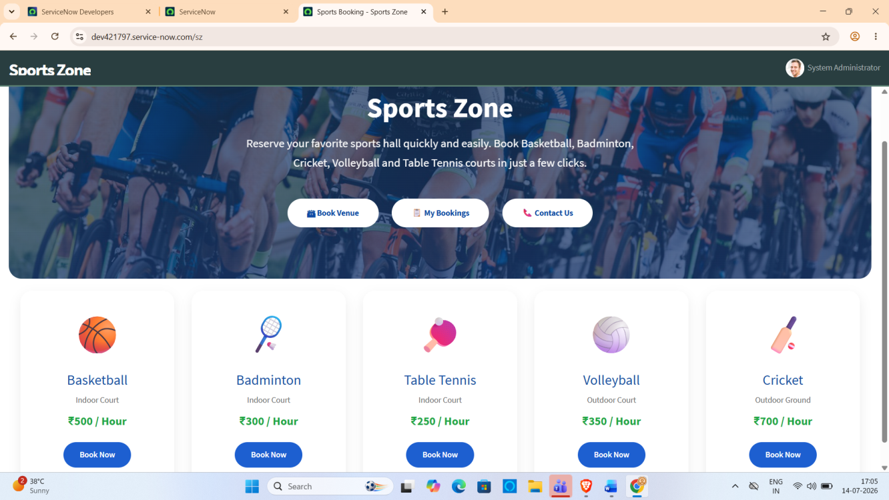

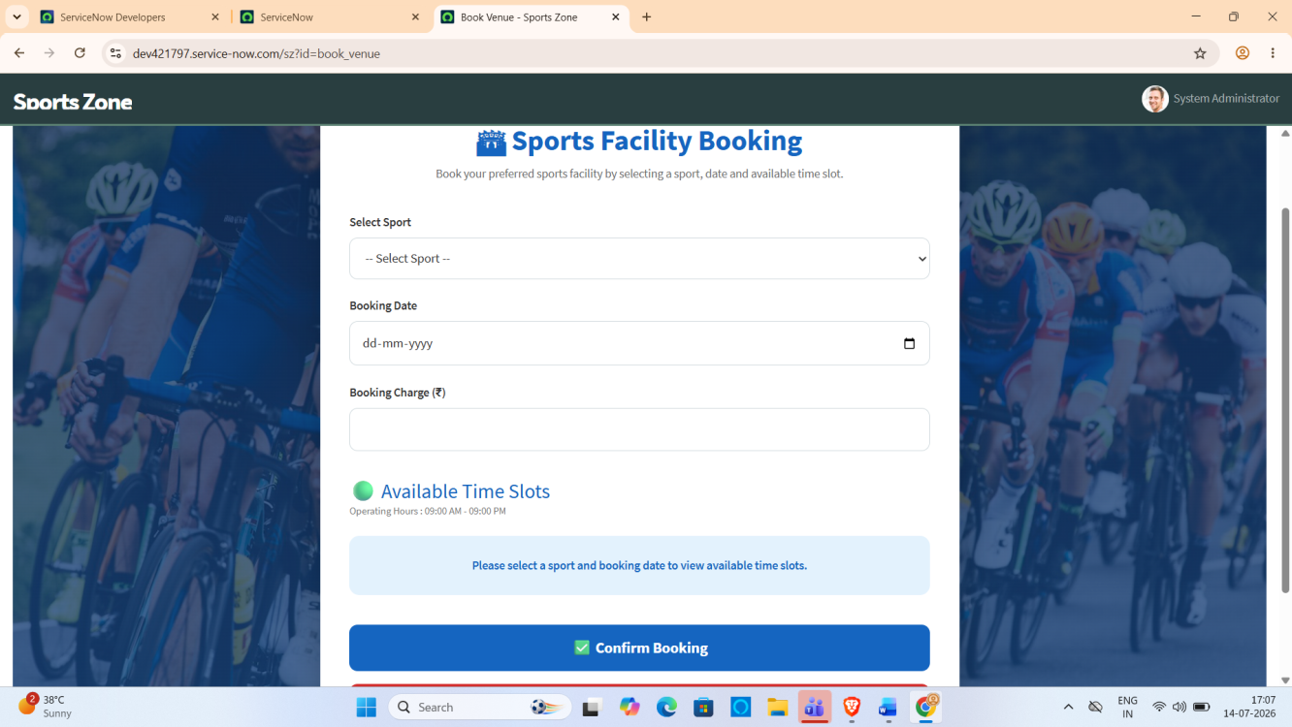
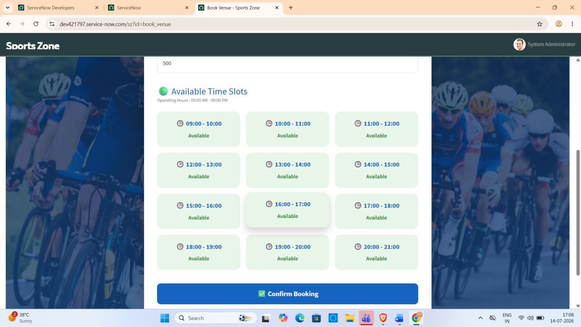

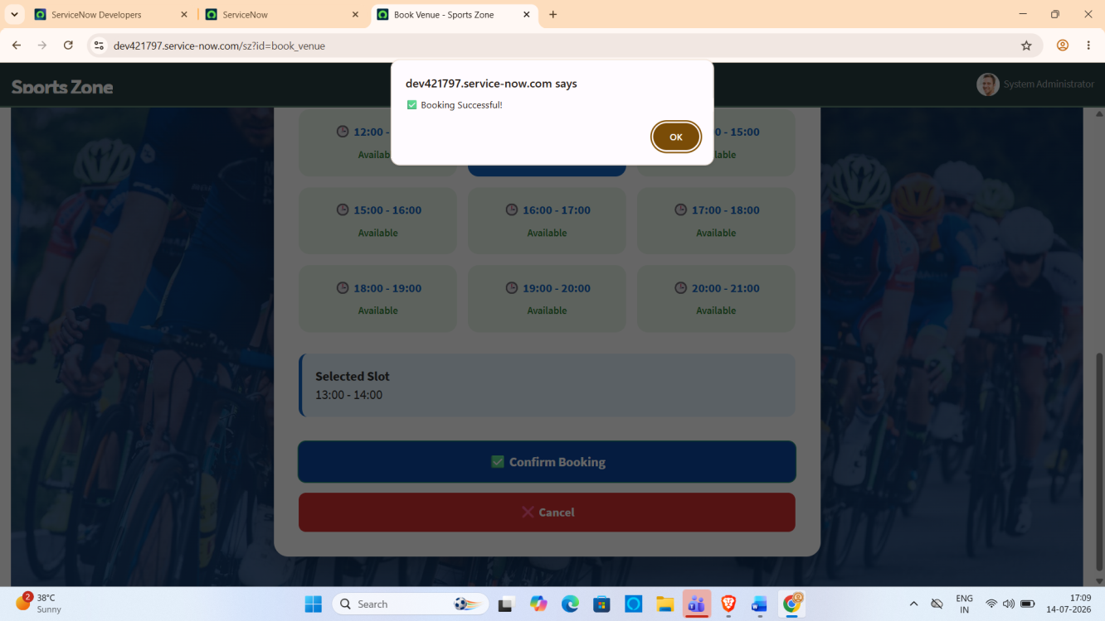

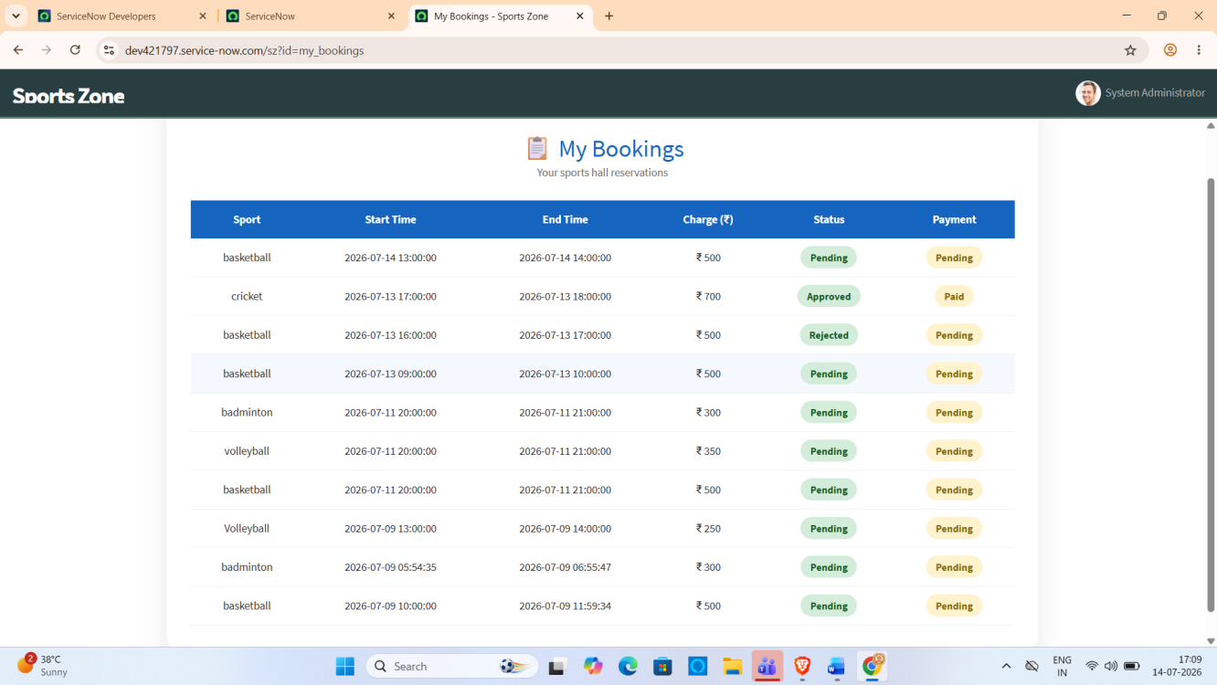

10. Testing Strategy
The Sports Hall Booking System was tested to ensure that all implemented functionalities work correctly and meet the project requirements. Testing focused on verifying data accuracy, booking validation, portal functionality, and notification configuration. Both backend and frontend components were tested using different input scenarios to ensure reliable system performance.

Functional Testing Summary
Functional testing was carried out to verify that every feature of the application worked according to the specified requirements. The following functionalities were successfully validated:
- Sports selection
- Booking date selection
- Display of available slots
- Booking charge calculation
- Booking confirmation
- Duplicate booking prevention
- Cancel booking functionality
- Navigation between pages
All planned functional test cases were executed successfully without critical failures.

User Acceptance Testing
User Acceptance Testing (UAT) was performed to ensure that the developed application satisfies user expectations and business requirements. During UAT, users verified the complete booking process from selecting a sport to confirming a reservation.
The system successfully displayed available slots, prevented duplicate bookings, calculated booking charges correctly, and redirected users after successful booking. Feedback received during testing confirmed that the application was easy to use and met the intended objectives.

Bug Resolution
During development, a few issues were identified and resolved before the final deployment.
Issue | Resolution
Booked slots appeared in available slots | Modified the server-side slot validation logic.
Booking charge not updating | Updated the Client Controller to refresh charges dynamically.
Duplicate booking validation delay | Improved server-side validation before booking confirmation.
After resolving these issues, the application functioned correctly and all major features were successfully verified.

11. Screenshots or Demo









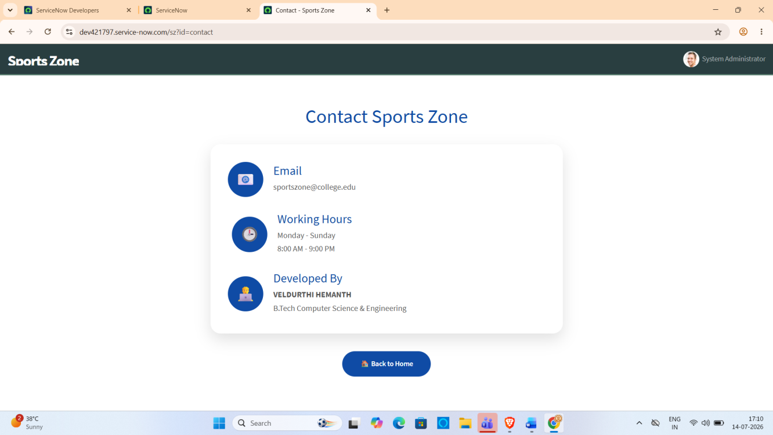

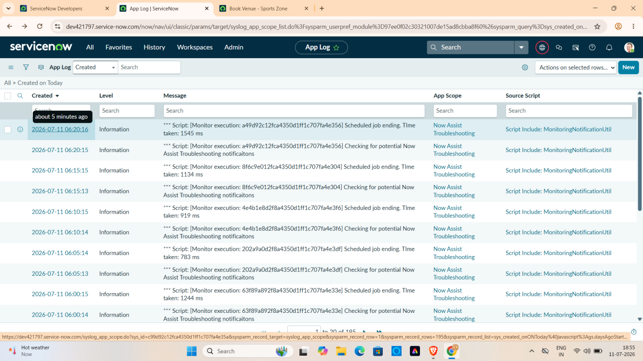

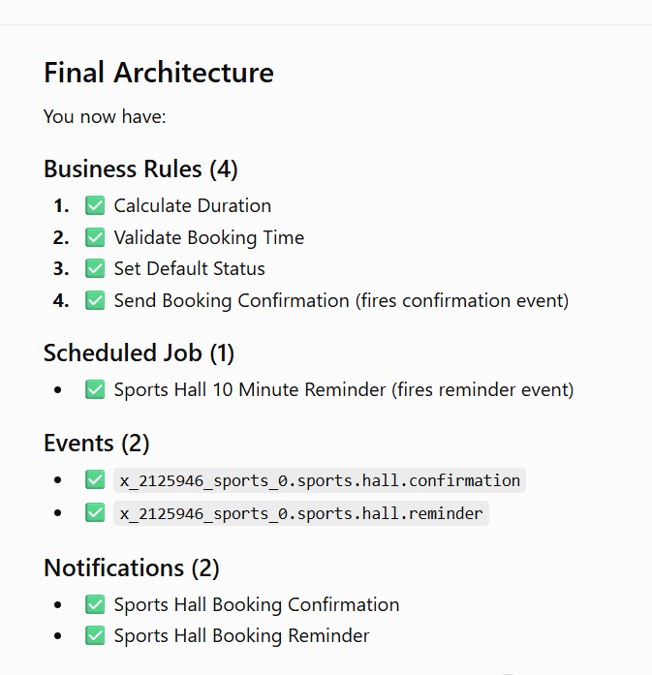

GitHub Repository:

https://github.com/228x1a05g6-dev/Sports-Hall-Booking-System-by-Service-Portal

Demo
Link :

https://drive.google.com/file/d/1RwufHAbRpZVH04mrXSigWn6UKQYuklkV/view?usp=sharing

- Known Issues :

Although the Sports Hall Booking System meets the project requirements, a few limitations were observed during implementation:

The system is currently designed for internal users within the ServiceNow environment and does not support public user registration.

Sports hall availability is managed through the existing booking records, but advanced calendar-based slot visualization is not available.

The application focuses on the core booking workflow and does not include payment processing or billing features.

One more thing system time zone and present user time zone is different

The current implementation supports the project requirements but may require optimization for handling a large number of simultaneous booking requests.
- Future Improvements

The Sports Hall Booking System can be enhanced further with the following features:

Develop a dedicated admin dashboard with graphical booking statistics and utilization reports.

Add a calendar view to display hall availability and upcoming bookings.

Implement online payment integration for paid sports facilities.

Introduce QR code or digital pass verification for booked halls.

Add SMS and mobile push notifications for booking confirmations and reminders.

Develop a mobile-friendly application for easier access across devices.

Implement waitlist functionality when all slots are occupied.

Add role-based enhancements for sports coordinators and facility managers.

Integrate with institutional calendars and event management systems.

Improve scalability and performance to support a larger number of users and multiple sports facilities.

